### Cloud computing offers numerous advantages, including cost savings, enhanced scalability, increased flexibility, improved security, and better collaboration. It also enables easier access to data and applications from anywhere with an internet connection, leading to greater productivity and a competitive edge

### **Cloud advantage**

### **Cost Savings**

* **Reduced Infrastructure Costs** – No need to buy or maintain physical servers and data centers.
* **Variable Expenses** – Pay only for what you use; shift from capital to operational expenses.
* **Optimized Resource Utilization** – Avoid over-provisioning; scale precisely as needed.

### **Scalability and Flexibility**

* **On-Demand Resources** – Instantly scale resources up or down to match demand.
* **Flexibility in Deployment** – Rapidly deploy apps and services, shortening time-to-market.
* **Disaster Recovery** – Built-in, reliable disaster recovery solutions for business continuity.

### **Improved Security**

* **Enhanced Security Measures** – Enterprise-grade security infrastructure and monitoring.
* **Data Encryption and Access Controls** – Protects data and restricts unauthorized access.
* **Regular Security Updates** – Automatic updates to counter emerging security threats.

### **Collaboration and Accessibility**

* **Remote Access** – Access files and tools from anywhere with an internet connection.
* **Simplified Collaboration** – Real-time team collaboration across locations.
* **Data Sharing and Version Control** – Easy sharing with built-in version management.

### **Other Benefits**

* **Automatic Software Updates** – Cloud providers manage maintenance and updates.
* **Sustainability** – Reduces hardware waste and energy consumption.
* **Access to Cutting-Edge Technologies** – On-demand access to AI, ML, big data, etc.

**Jenkins**

https://docs.google.com/document/d/1fbPxQd9Xq_vLTTV800q9T4es222JmaU3QSXPVClQS5s/edit?tab=t.0#heading=h.75dqi6kl9neu

Jenkins intsall —- Done

Tomcat setup — Done

Git setup — Done

Maven Setup — Done

Configuration –Done - JENKINS_HOME" environment variable

Management –Done

Setup Build Jobs — Done

installing Jenkins > = **http://localhost:8080**

installing Tomcat >= **http://localhost:8081**

# Downloading Apache Maven 3.9.9

Manage jenkins > tools > add maven with path of maven

In jenkins > plugins > maven integration plugin

> plugins > xunit plugin

Create new item > free style project

**Method 1**

In build steps > execute windows batch command

**Command**

java filename.java

java filename

Or

java filename.java

java filename.java

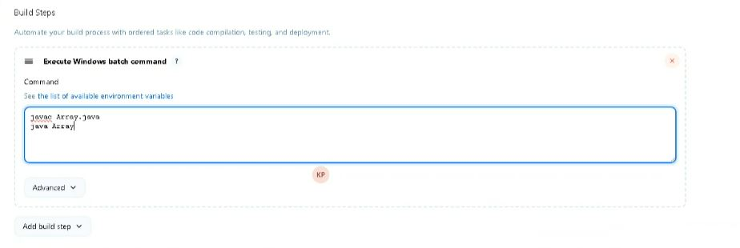

**Method 2**

**Source code management**

**Git > url repository of git**

**In branch > give which branch the file name have**

**Method 3**

**In general > advance > use custom workspace**

**Copy path in your computer where the file there**

**After creating new items > click build play symbol**